SONARCUBE With JENKINS
Start Jenkins
- sudo systemctl start Jenkins
- goto> manage Jenkins> plugins>Available plugins>SonarCube Scanner For Jenkins
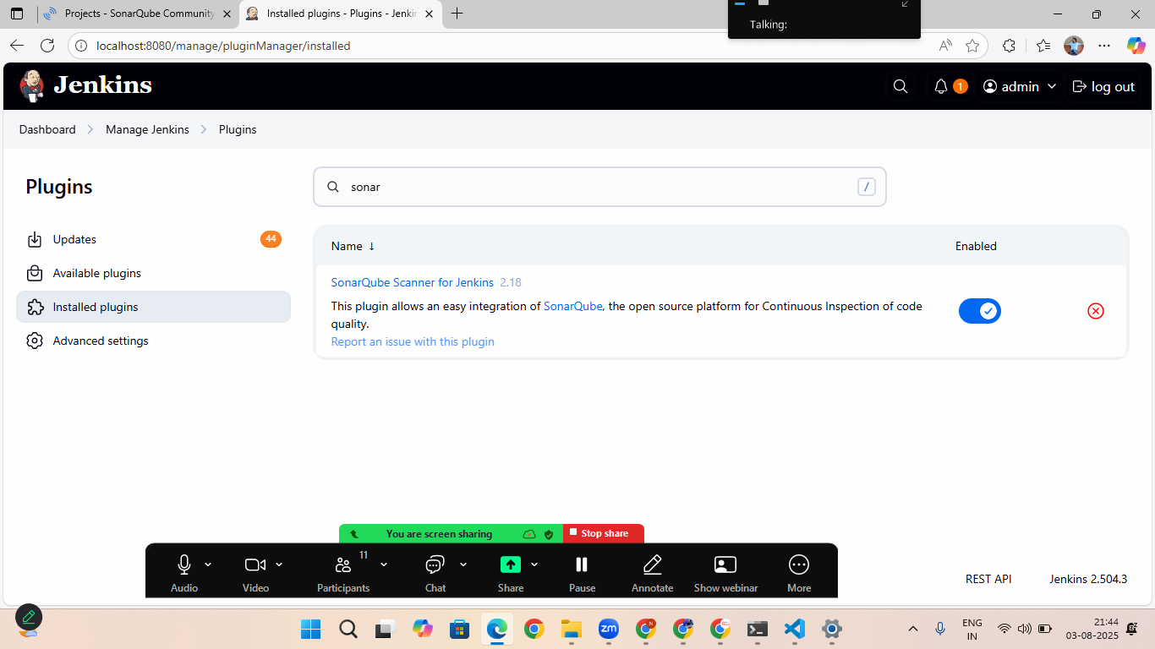
- setup token from global tool configuration
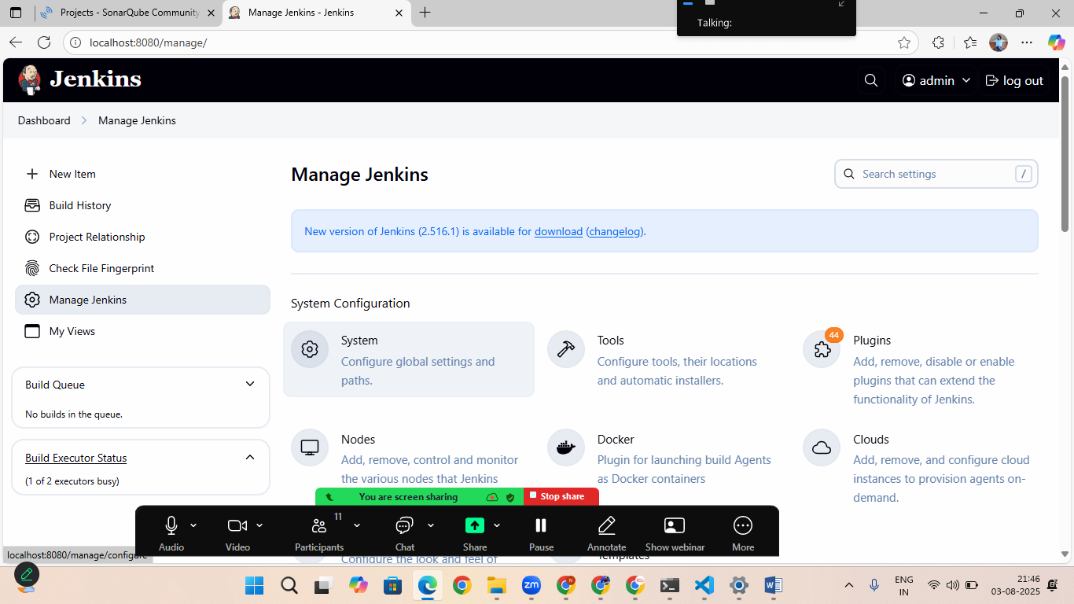

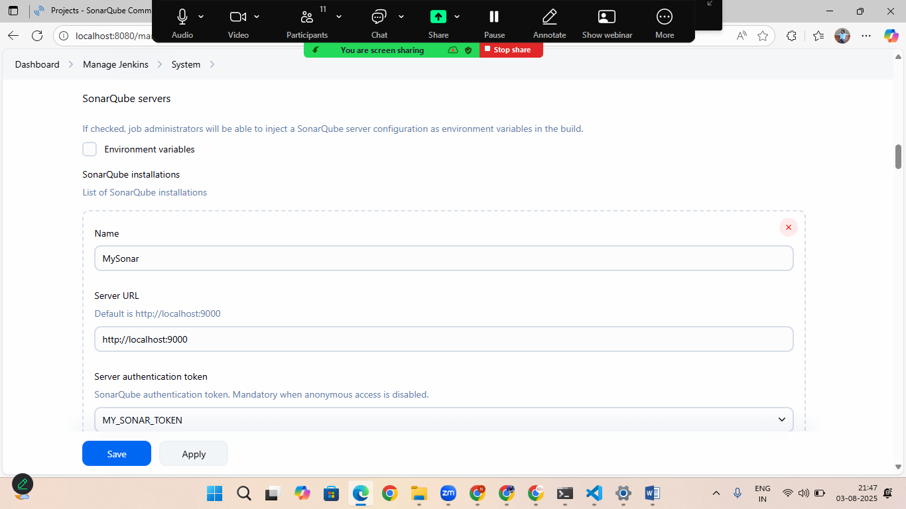

In server authentication token> add secret file>
Click on add> choose jenkins
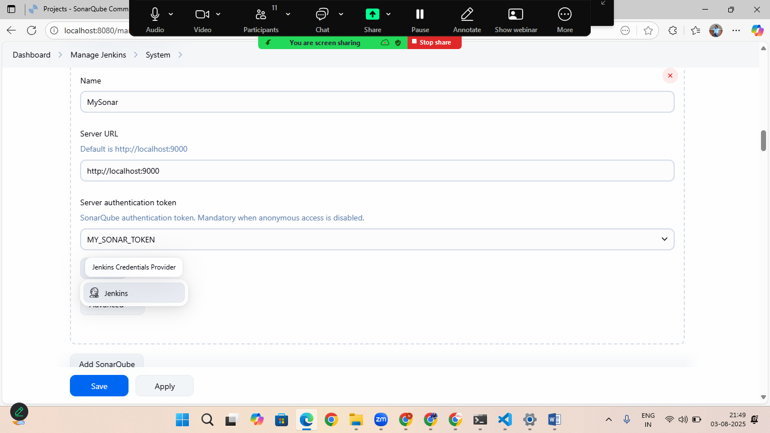
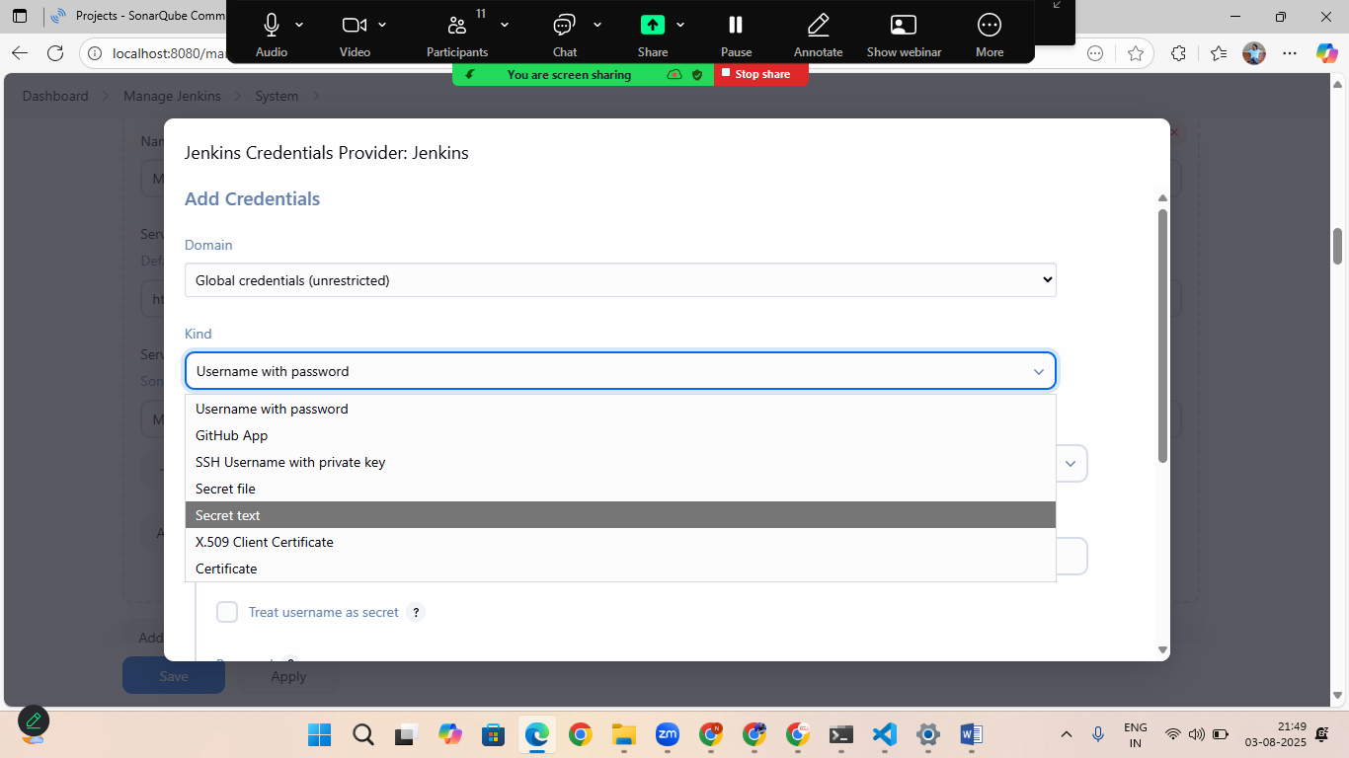
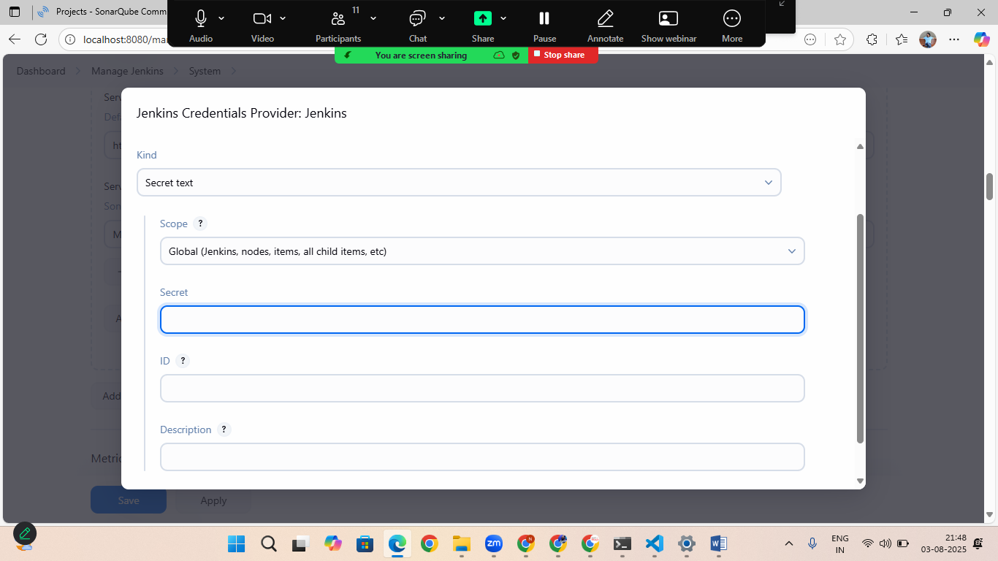
In secret add your sonarcube token
Click save and apply

